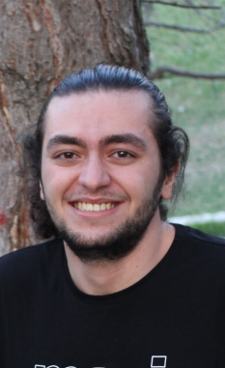

**Ahmet Furkan CELIK**

Nationality : Turkish

Date of Birth : 16.11.1998

Phone : +90-533-311-76-99

E-mail : frknclkclk@icloud.com

Address: : Uyanış Mah. 1083 Sok. Beyza Apt. No: 4/2

Keçiören ANKARA

Computer Engineering Student

I have been interested in computers for a long time. I can find and solve most of the problems about these. I like playing video games, reading books, outdoor sports like orienteering and camping and, I enjoy engaging in sea sports such as swimming and sailing. I am pretty good at communicating with people. I am currently a third-year computer engineering undergraduate program student. I am open to improving myself and willing to learn about everything, not just technical issues.

**EDUCATION**

**High School : TED College**

**University : Gazi University Computer Engineering**

**ABILITIES**

**English - C1**

**Html/Css**

**Java**